Adding Data from a Second Data Source to an Existing Data Source
Product(s): Tableau Desktop, Tableau Public
Version(s): 6.1, 6.0
Last Modified Date: 19 Jun 2014
Article Note: This article is no longer actively maintained by Tableau. We continue to make it available because the information is still valuable, but some steps may vary due to product changes.

You can add data from another data source to a data source already in use in a Tableau workbook. This example starts with a workbook using data from Microsoft Excel, and then adds data from Microsoft Access. The key to adding data is creating a calculated field that represents the added source, and using it in the view.
Note: The dimensions used in the view must be present in both data sources and contain the same values. If blending with a cube data source, it is only valid as the primary data source.

Set up the initial workbook

Step 1
Open a new workbook and connect to the Superstore sample.

Step 2
From the Dimensions pane, drag Order Date to the Columns shelf.

Step 3
On the Columns shelf, right-click Order Date and select Show Quick Filter.
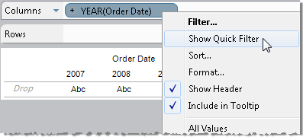

Step 4
In the quick filter, click the check box for All to clear all the selections, and then select 2009.

Step 5
On the Columns shelf, click the plus sign on YEAR(Order Date). QUARTER(Order Date) appears on the Columns shelf next to YEAR(Order Date).

Step 6
Drag QUARTER(Order Date) to the Rows shelf.

Step 7
From the Dimensions pane, drag Category to the Columns shelf.

Step 8
From the Measures pane, drag Sales to the Text shelf on the Marks card. Now the view for Superstore by itself is complete.

Step 9
Select Data > Connect to Data and connect to a second data source. For more detailed information, refer to the "How to Connect to a Data Source" section of the Online Help.

Create relationships to blend the data

Step 1
In the Data window, select the second data source.
In the example, notice the link icon in the Dimensions pane next to Order Date. This icon indicates that Tableau has automatically created a relationship between Order Date in the second data source and Order Date in the primary data source. The relationship was created automatically because the dimensions have the same name in both data sources.
Every dimension used in the view must have a relationship with its counterpart in the other data sources. In this example, Category field in Superstore needs a relationship with Product Type field in the secondary data source. Tableau did not create an automatic relationship because the names are different, so you need to create a custom relationship.

Step 2
In the Data window, select Superstore.

Step 3
For Tableau Desktop 7.0 and later, select Data > Edit Relationships.
For Tableau Desktop 6.1 and earlier, in the Data window, right-click Superstore and select Relationships.
In the Relationships dialog box, you can see that Tableau has created many automatic relationships. The automatic relationship does not include Category in the secondary data source source to Category in Superstore.

Step 4
In the Relationships dialog box, select Custom, and then click Add.

Step 5
In the Add/Edit Field Mapping dialog box, in the Primary data source field list, select Category.

Step 6
In the Secondary data source field list, select Product Type, and click OK.
In the Relationships dialog box, the custom relationship has been added to the list.

Step 7
Click OK.
If you select the secondary data source in the Data window, you see that a link icon now appears next to Product Type.

Create calculated fields to distinguish and combine sales data
You need to create a calculated field for sales from the secondary data source and one for the combined total. In this example, the secondary data source is Sample - Coffee Chain (Access).

Step 1
In the Data window, select Superstore.

Step 2
Select Analysis > Create Calculated Field.

Step 3
In the Calculated Field dialog box, make the following selections to create this formula:
ZN(SUM([Sample - Coffee Chain (Access)].[Sales]) )
- In the Name text box, type Sales - Coffee Chain.
- Click the Formula text box.
- In the Functions list, double-click ZN.
- In the Fields drop-down list, select Sample - Coffee Chain (Access).
- In the Fields list, double-click Sales.

Step 4
When finished, click OK.
Now create a calculated field for the Total Sales.

Step 5
Select Analysis > Create Calculated Field.

Step 6
In the Calculated Field dialog box, make the following selections to create this formula:
IF ISNULL([Sales - Coffee Chain]) THEN 0 ELSE [Sales - Coffee Chain] END
+
IF ISNULL(SUM([Sales])) THEN 0 ELSE SUM([Sales]) END
- In the Name text box, type Total Sales.
- Click the Formula text box.
- In the Functions list, double-click IF, then ISNULL.
- In the Fields drop-down list, select Superstore.
- In the Fields list, double-click Sales - Coffee Chain.
- Click outside the closing parenthesis, space, type THEN 0 ELSE, and space again.
- In the Fields list, double-click Sales - Coffee Chain.
- Add a space, and type END.
- Start a new line, and type a plus sign.
- Start another new line, and in the Functions list, double-click IF, ISNULL, and then SUM.
- In the Fields list, double-click Sales.
- Click outside the closing parenthesis, space, type THEN 0 ELSE, and space again.
- In the Functions list, double-click SUM.
- In the Fields list, double-click Sales.
- Add a space, and type END.

Create a blended view

Step 1
For Tableau Desktop version 7.0 and later, right-click the worksheet tab and select Duplicate Sheet.
For Tableau Desktop version 6.1 and earlier, select Edit > Duplicate Sheet.

Step 2
From the Dimensions pane, drag Measure Names to the Rows shelf.

Step 3
On the Rows shelf, right-click Measure Names and select Show Quick Filter.

Step 4
In the Measure Names quick filter, click the All check box to clear all the selections, and then select Sales.

Step 5
From the Measures pane, drag Measure Values to the Text shelf on the Marks card.
A Measure Values shelf opens.

Step 6
From the Measures pane, drag Sales - Coffee Chain and Total Sales to the Measure Values shelf.
Now the view shows the sales figures from both data sources, and the total, for each quarter of 2009.
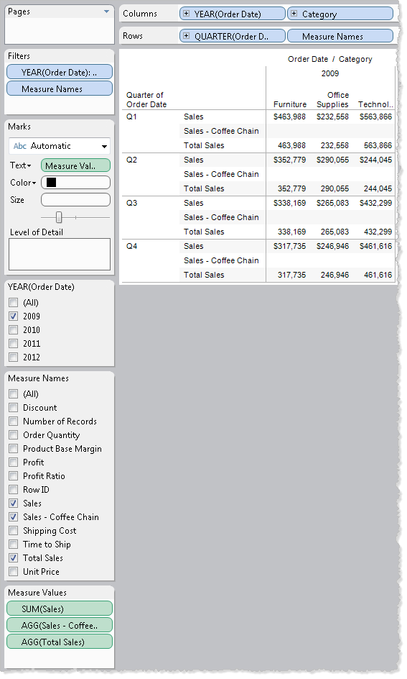

Combining Multiple Data Sources into One View
Product(s): Tableau Desktop
Version(s): All
Last Modified Date: 19 Jun 2014
Article Note: This article is no longer actively maintained by Tableau. We continue to make it available because the information is still valuable, but some steps may vary due to product changes.

Beginning with Tableau 6.0, you can use multiple data sources for a single worksheet. One data source is primary; all others are secondary. For the primary resource, Tableau selects the data source of the first field you add to the view. Or, if one of your data sources is a cube, it must serve as the primary data source. The primary data source creates relationships with fields of the same name and data type that it finds in the other data sources.
To create a view from multiple data sources, you complete these tasks:
- Connect to the data sources.
- Create a master data source that combines the data sources.
- Create calculated fields to distinguish and combine data.
- Create relationships among the data sources.
- Create the combined view.
The sections in this article step through these tasks using data from two fictional retail stores, each differing from the other in the types of product sold and the reporting data format used. All other data is the same.

Connect to the data sources

Step 1
Open a new workbook and connect to the Superstore sample.

Step 2
Select Data > Connect to Data, and connect to the Coffee Chain sample.

Create a master data source that combines the data sources

Step 1
In a blank Excel worksheet, create the following list of all dimensions and measures needed in the final view. Type each term on its own row, all in the same column.
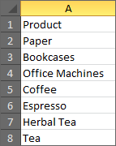 | - Product  - Paper  - Bookcases  - Office Machines  - Coffee  - Espresso  - Herbal Tea  - Tea
Note: If your data requires additional dimensions, you must repeat them for each value. For example, if you also wanted to display the years in the data, the product list would need to be repeated for each year.

Step 2
In the Excel worksheet, select the list you just created, and then copy it to the Clipboard.

Step 3
Select Data > Paste Data.
Note: In Tableau Desktop 6.1 and earlier, select Edit > Paste Data.

Step 4
From the Clipboard data connection, drag Product to the Columns shelf.
Because the Product field is the first to be placed in the view, a blue circle with a check mark identifies the Clipboard data as the primary data source. You can switch to another source by clicking its title bar in the Data window.
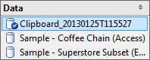

Create calculated fields to distinguish and combine sales data
In this section, you create a calculated field to represent Superstore sales, one for Coffee sales, and one that provides a way to add these values to a table of combined sales data.

Step 1
Select Analysis > Create Calculated Field.

Step 2
In the Calculated Field dialog box, complete the following steps.
- For Name, type Sales Superstore.
- In the Formula box, build the following formula:
ZN(SUM([DATA-SOURCE-NAME].[Sales]))
replacing DATA-SOURCE-NAME with the name of your Superstore sample. The one used to create this article is called Sample - Superstore Subset (Excel).
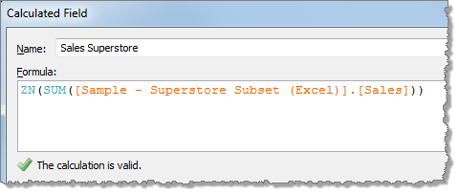
- Confirm that the status message indicates that the formula is valid, and then click OK.

Step 3
Create a second calculated field, naming it Sales Coffee, and using the following formula:
ZN(SUM([Sample - Coffee Chain (Access)].[Sales]))
Replace Sample - Coffee Chain (Access) with the name of your Coffee Chain sample if it differs.
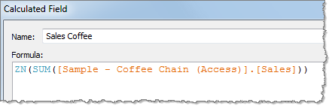

Step 4
Create a third calculated field, naming it Sales Works, and using the following formula:
IF ISNULL([Sales Coffee]) THEN 0 ELSE [Sales Coffee] END +
IF ISNULL([Sales Superstore]) THEN 0 ELSE [Sales Superstore] END
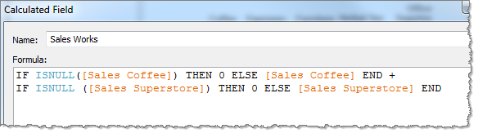
This formula tells Tableau that if the value is null, put a zero value in the table; otherwise, insert the value itself. You can add as many lines to this calculation as you need for each data source used in the table.

Create relationships among the data sources
Remember that Tableau designated the Clipboard data as the primary data source, because the first field you placed into the view was from this data source. This section steps through linking Clipboard to the two secondary data sources. It does this through corresponding fields, in a manner similar to the way you set up joins.

Step 1
Select Data > Edit Relationships.
Note: In Tableau Destkop 6.1 and earlier, in the Data window, right-click Clipboard and select Relationships.

Step 2
In the Relationships dialog box, complete the following steps to set up the relationship among the data sources.
- In the Secondary data source list, select the coffee chain data source.
- Select Custom, and then click Add.
- In the Add/Edit Field Mapping dialog box, select Product on the left and Product Type on the right, and then clickOK.
The Product field from the Clipboard data source is now linked to the Product Type field in the coffee chain data source.
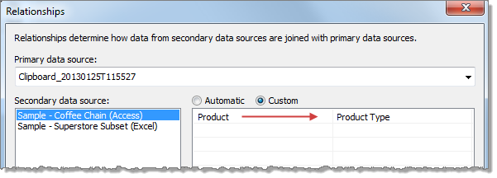
Note: If a default mapping shows Product mapped to Product, remove that mapping by clicking the red X that appears when you hover the mouse over the mapping.
- In the Secondary data source list, select the Superstore data source, and repeat the previous steps to map the Clipboard Product field to the Superstore Category field.
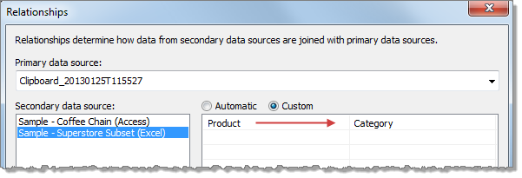
- Click OK in the Relationships dialog box.

Step 3
In the Data window, select each secondary data source to confirm that, in the Dimensions pane, a link icon appears as a visual indicator next to the linked fields.
In the Coffee Chain data source, the indicator appears next to Product Type.
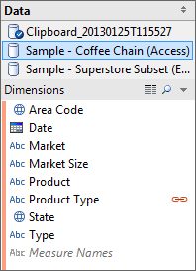
In the Superstore data source, the indicator appears next to Category.
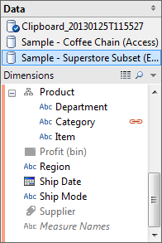

Create the combined view

Step 1
Select Worksheet > New Worksheet.
Note: In Tableau Desktop 6.1 and earlier, select Edit > New Worksheet.

Step 2
In the Data window, select the Clipboard data source, and from the Dimensions pane, drag Product to the Rows shelf.

Step 3
Select the Coffee Chain data source, and from the Dimensions pane, drag Product Type to Detail on the Marks card.

Step 4
Select the Superstore data source, and from the Dimensions pane, drag Category to Detail.
If an alert appears to indicate that you could use a join here, you can ignore the message for this scenario.

Step 5
In the Data window, select the Clipboard data source.

Step 6
In the Measures pane, double-click each of the calculations you created earlier:
Sales Coffee, Sales Superstore, and Sales Works.
The measures are added to the Measure Values shelf and the view.

Step 7
If the automatic view associates the values with color, you can change the view so that the values appear instead. On the Marks card, drag Measure Values to Label.
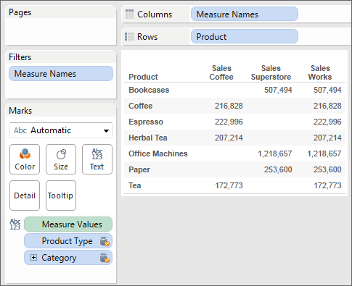

Step 8
Select Analysis > Totals > Show Column Grand Totals.
Note: In Tableau Desktop 6.1 and earlier, select Table > Column Grand Totals.
The table shows sales from the Coffee Chain and Superstore files, as well as their combined total.
Alternate Search Terms: primary, secondary, cube, data source, datasource, blending

